**END SEMESTER MP LAB PRACTICALS**

**Name:** Rahul Ram M

**Roll No.:** 185001121

**Date:** 17/11/2020

**29.a. Write an ALP using 8051 to sort a list of numbers in ascending order.**

**Aim:**

To write an ALP using 8051 to sort a list of numbers in ascending order.

**Algorithm:**

* Move the length of the list to R1.
* Move the value of R1 to register A and from register A to R2.
* LOOP1: Move the value of R1 to register A.
* Decrement the value of register A and move the value of register A to R3.
* Move the starting location(10H) of the list to R0.
* LOOP2: Move the contents stored in the memory location specified by R0 to register A.
* Increment R0 to move to next location.
* Now move the contents stored in the memory location specified by R0 to register B.
* Clear the carry flag.
* Subtract A from B.
* If carry is produced, value at A and B are already in order so move to SKIP.
* Else A and B are out of order.
* Decrement R0 to move one step back in the memory.
* Copy the contents at that memory location to register A and store the value of register B to that location.
* Increment R0 to move to the next memory and store the value of register A to that location.
* SKIP: Using DJNZ decrement the value of R3 and check if it is 0. If not loop to LOOP2 else execute the next instruction.
* Using DJNZ decrement the value of R2 and check if it is 0. If not loop to LOOP1 else execute the next instruction.
* END: Using SJMP END, create an infinite loop to END by unconditional jump to END.

**Code:**

MOV R1, #06H

MOV A, R1

MOV R2, A

LOOP1: MOV A, R1

DEC A

MOV R3, A

MOV R0, #010H

LOOP2: MOV A, @R0

INC R0

MOV B, @R0

CLR C

SUBB A, B

JC SKIP

DEC R0

MOV A, @R0

MOV @R0, B

INC R0

MOV @R0, A

SKIP: DJNZ R3, LOOP2

DJNZ R2, LOOP1

END: SJMP END

**Output:**

**Unsorted:**

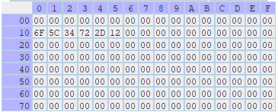

**Sorted:**

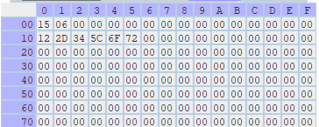

**Result:**

ALP using 8051 to sort a list of numbers in ascending order is executed successfully.

**29.b. Write an ALP using 8086 to find the number of ones and zeros in a 16-bit number.**

**Aim:**

To write an ALP using 8086 to find the number of ones and zeros in a 16-bit number.

**Algorithm:**

* START: Move the starting address of data segment to AX register and move the data from AX register to DS register
* Initialize the BX register to 0.
* Copy the value of num to AX register.
* Move 10H (16) to CX register.
* L1: Using RCR (rotate through carry right), rotate the bits to the right in the AX register including the carry by 1.
* So, the least significant bit of AX register will move to CF.
* Using JC, check if the CF contains 0 or 1. If it is 0, jump to ONE.
* Else increment BL (number of zeros) and take unconditional jump to HERE.
* ONE: increment BH register (number of ones).
* HERE: Loop through l1 till CX becomes 0.
* Move the value of BL register to zeros and BH register to BH.
* Using INT21H with AH value as 4CH, terminate the program.

**Code:**

; counting number of zeros and ones in a 16-bit number

assume cs:code, ds:data

data segment

num dw 0abcdh

zeros db 00h

ones db 00h

data ends

code segment

org 0100h

start: mov ax, data

mov ds, ax

mov bx, 0000h

mov ax, num

mov cx, 0010h

l1: rcr ax, 1

jc one

inc bl

jmp here

one: inc bh

here: loop l1

mov ones, bh

mov zeros, bl

mov ah, 4ch

int 21h

code ends

end start

**Output:**

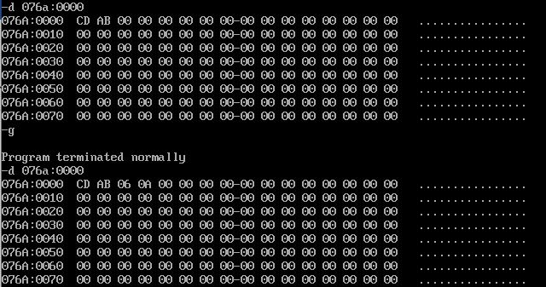

**Result:**

ALP using 8086 to find the number of ones and zeros in a 16-bit number is executed successfully.